Scoots site plan

Site purpose

The purpose of scoots is to rent motorized vehicles such as scooters, ATVs, and jeeps to tourists in the city of Cozumel, Mexico. The primary goal is to appeal to tourists before they have left for their trip by having regarding services, the rental process, and requirements of renting readily available to visitors. This information must be easy and frustration-free to access and the site must be user-friendly. The site should exude a carefree environment and convince its visitors that renting from scoots will be a stress-free experience. The site will allow customers to make reservations of services and take payments for services online. It will also provide information about destinations to take rental equipment where customers can enjoy using the products. Customers should be able to purchase the service and know what to do with it all in one place.

Target audience

Scoots' products and services will appeal to both male and female customers in the middle and upper classes of wealth. As the majority of people making more than $50,000 a year is over the age of 30, the target audience will consist of a large age group between the ages of 35 – 50, as well as newly married couples. The audience will be from non-tropical climates. Visitors to the website will be able to access all features with a mobile device, tablet, or desktop.

Persona 1

Name: Cai Peng

Occupation: Financial Manager

Demographics:

* 49 years old
* 2 children ages 17 and 14
* Married
* Annual Combined Income: $160,000
* Lives in Pocatello, ID
* Chinese American Ethnicity

Goal: The trip to Cozumel is planned, but the rental car fell through and she’s looking for a more exciting option.

Persona 2

Name: Courtney Cox

Occupation: Stay-at-home-mom

Demographics:

* 42 years old
* 3 children ages 7, 10, and 15
* Married
* Annual Combined Income: $140,000
* Lives in Richmond, VA
* Caucasian Ethnicity

Goal: Plan the family vacation during the summer for her parents, four siblings, and 9 nieces/nephews.

Persona 3

Name: Ben Kenobi

Occupation: Technical Support Specialist

Demographics:

* 26 years old
* No children
* Not married
* Annual income: $55,000
* Lives in Phoenix, AZ
* Puerto Rican

Goal: He is helping his fiancé plan their honeymoon trip.

Site map

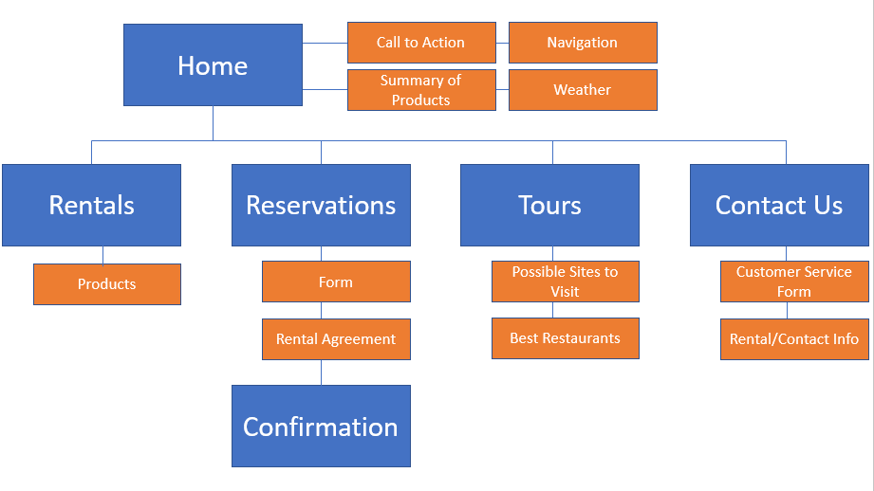

Color scheme

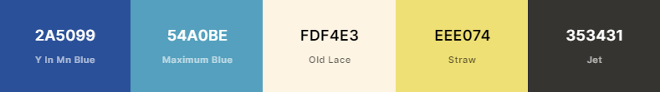

Typography

Header font is



Body font is

Wireframe sketches:

Respectively – Small, Medium, Large

